Farm Tycoon

Created by

**Nutthapong Dissanont 6530128321**

**Patthapol Kittikun 6530285121**

**2110215 Programming Methodology**

**Semester 1 Year 2023**

**Chulalongkorn University**

Farm Tycoon

-------------------------------------------------------------------

**Introduction**

Farm Tycoon is a farming simulator game inspired by Hay Day, in which players can plant diverse crops, raise adorable animals, sell products, and so much. Players can unlock various kinds of seeds, from crops to stunning flowers, and watch the farm flourish. The objective of this game is to build a thriving business and expand the farm.

**Main menu page**

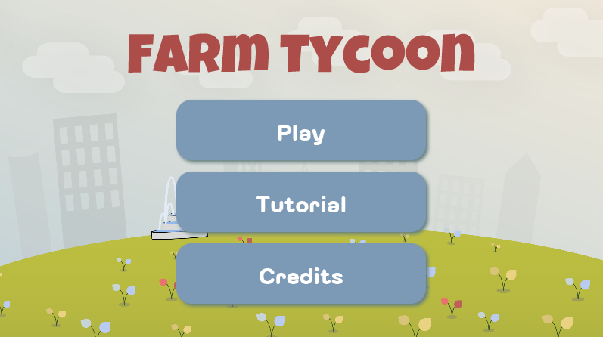

**How to play**

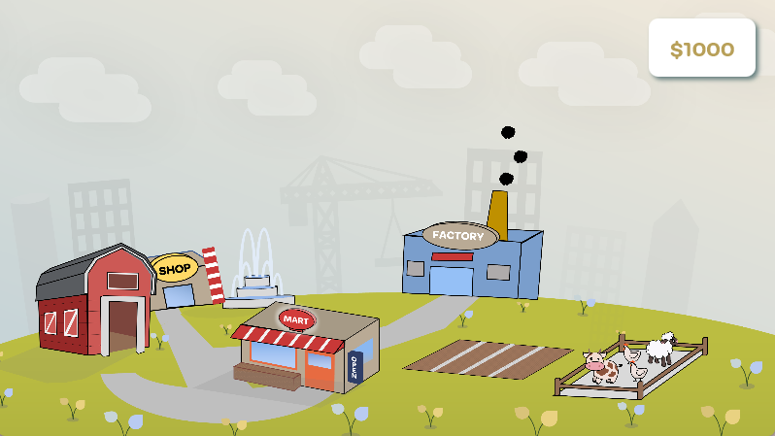

When start, the player will receive $1000 to initiate the farm business. There are 9 seeds in this game, i.e. wheat seed, carrot seed, pumpkin, seed, beetroot seed, berry seed, dandelion, seed, orchid seed, poppy seed, and tulip seed.

Each of them needs to be unlocked in the shop before they can plant except wheat seed that will be unlocked at the start of the game.

Players can plant all the seeds in plot and water them till they grow, and they can be harvested for products.

There are also 3 animals to raise including cow, chicken, and sheep which can have maximum of 4. Like seeds, the player can feed animals for products as well.

These products can be sold at minimart or can be used as raw materials in a factory to craft items such as bread, sweaters, cake, etc. for better selling price and become millionaire!

**Class Diagram**

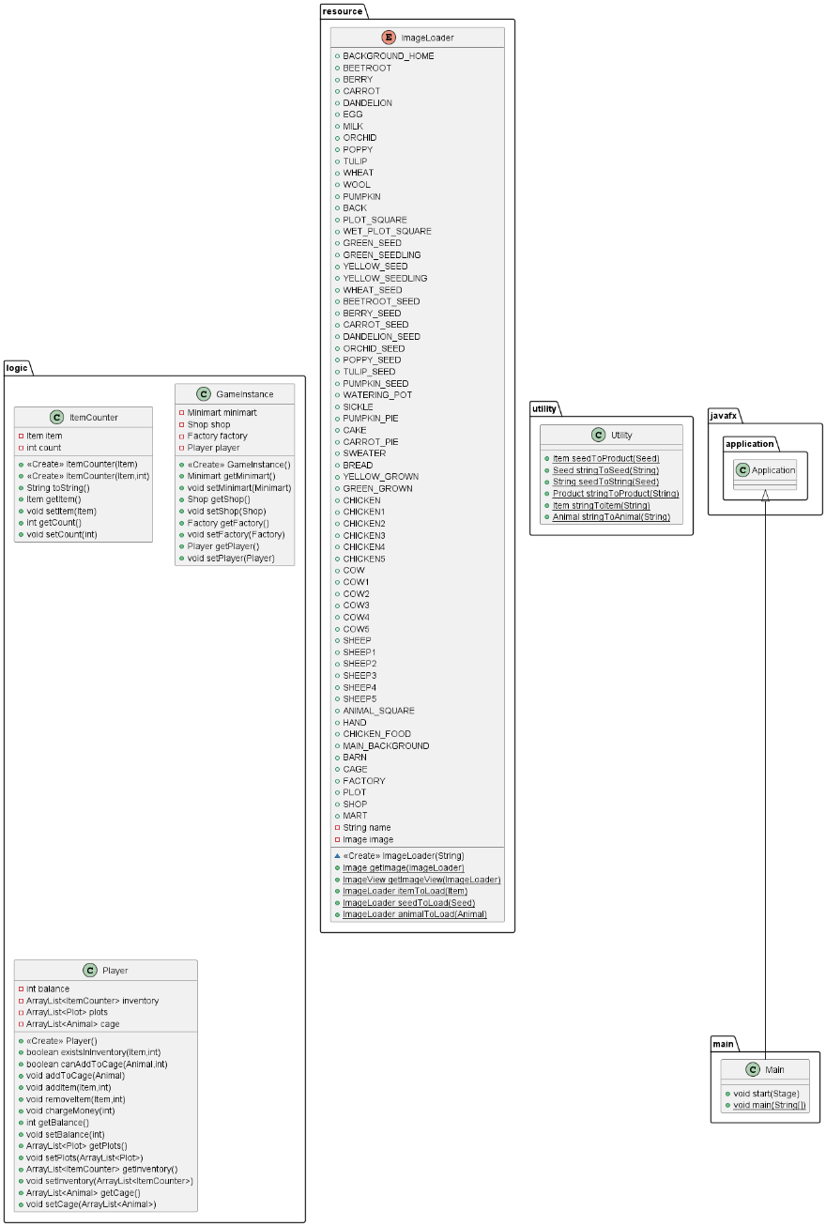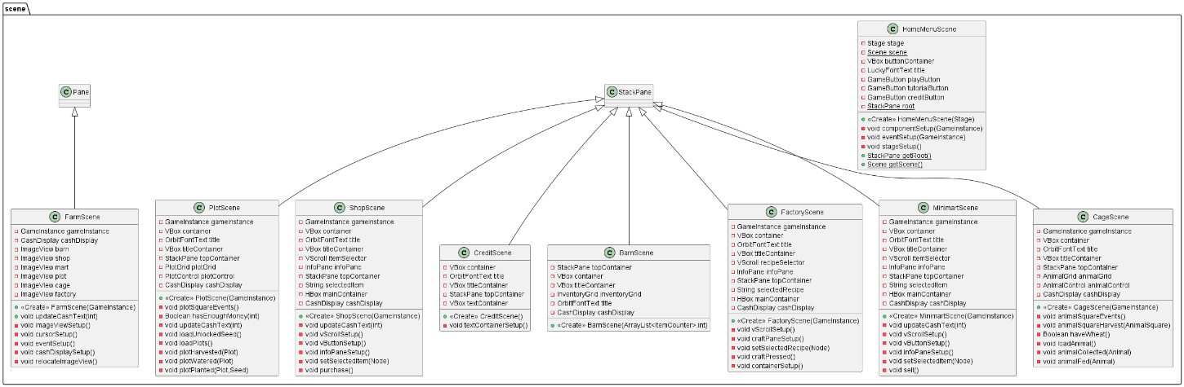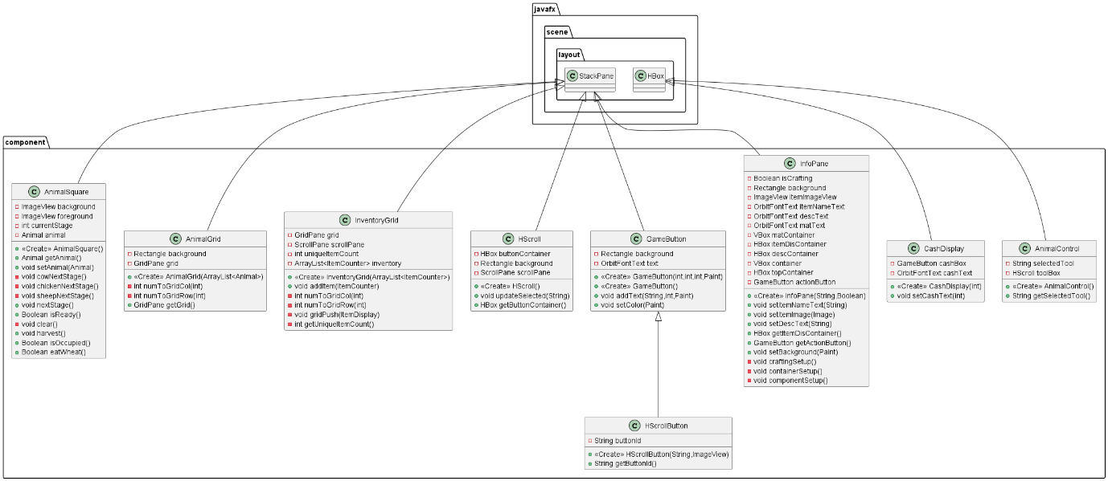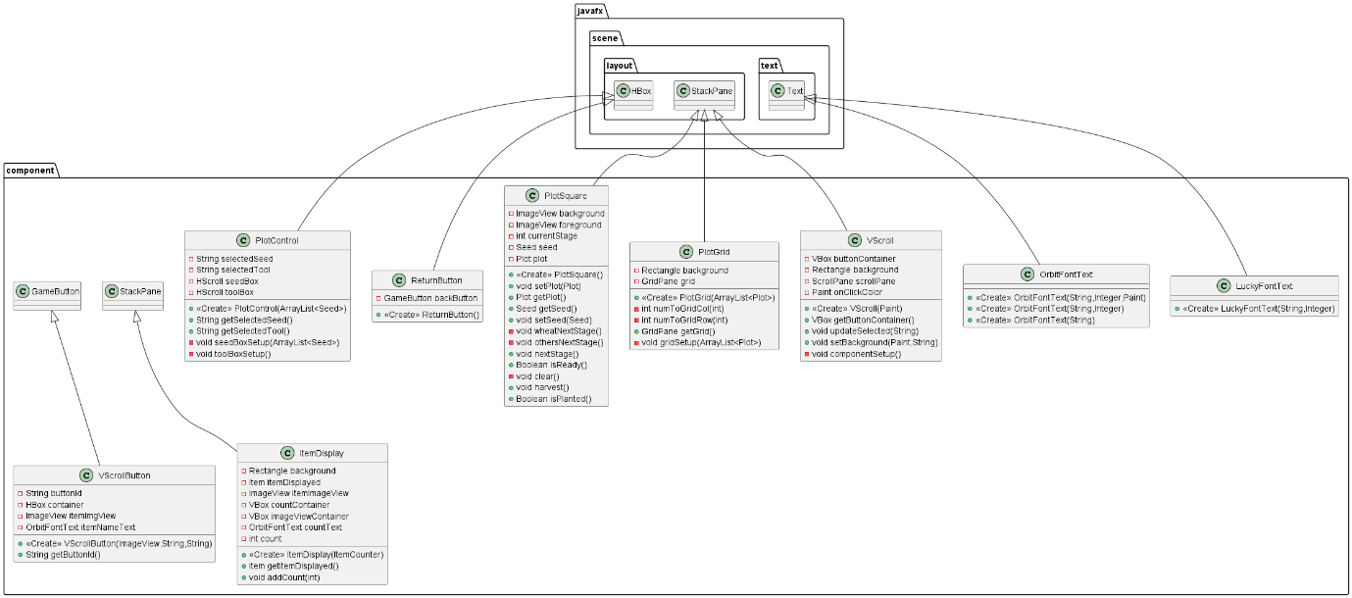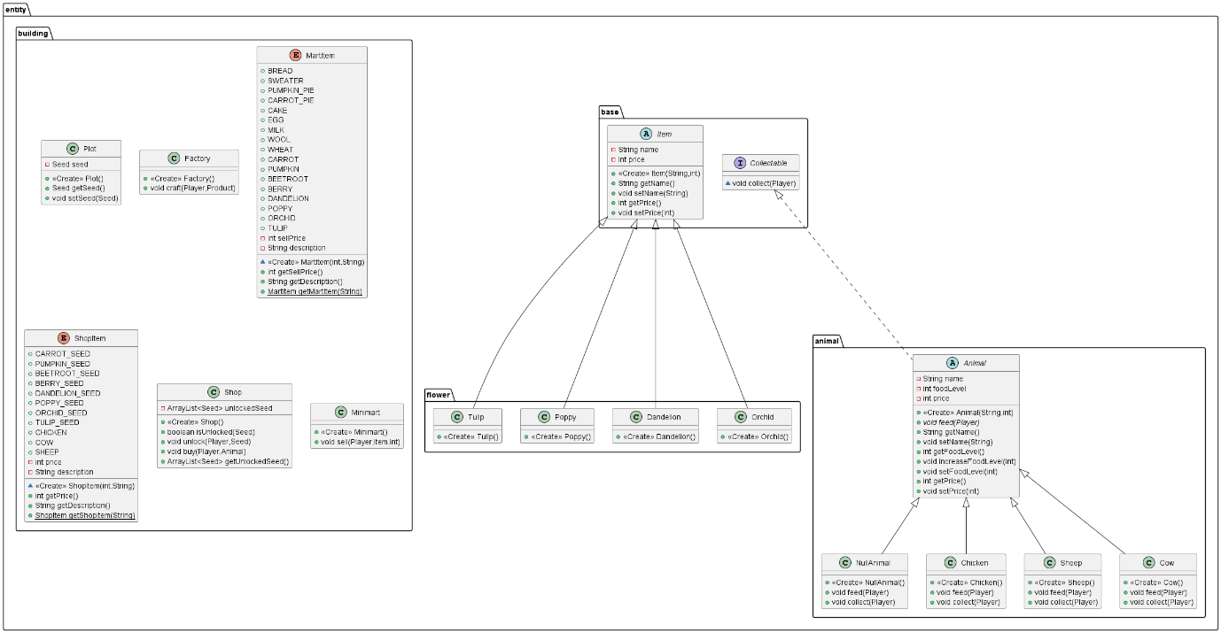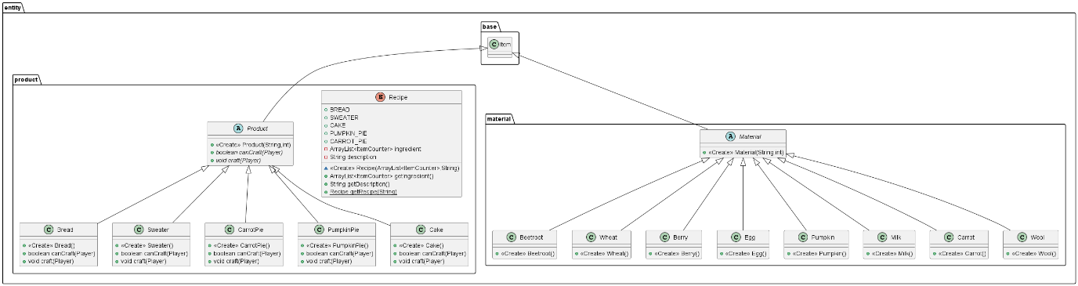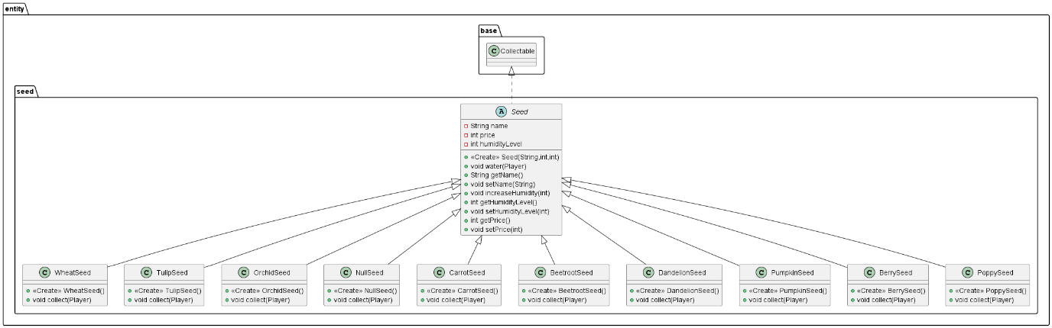

1. **Package logic**
   1. public class GameInstance

Field

|  |  |
| --- | --- |
| Name | Description |
| - Minimart minimart | Game minimart |
| - Shop shop | Game shop |
| - Factory factory | Game factory |
| - Player player | Game player |

Constructor

|  |  |
| --- | --- |
| Name | Description |
| + GameInstance() | Create GameInstance with new minimart, shop, factory, and player. |

Method

|  |  |
| --- | --- |
| Name | Description |
| + Minimart getMinimart() | Return game minimart |
| + void setMinimart(Minimart minimart) | Set game minimart |
| + Shop getShop() | Return game shop |
| + void setShop(Shop shop) | Set game shop |
| + Factory getFactory() | Return game factory |
| + void setFactory(Factory factory) | Set game factory |
| + Player getPlayer() | Return game player |
| + void setPlayer(Player player) | Set game player |

* 1. public class ItemCounter

Field

|  |  |
| --- | --- |
| Name | Description |
| - Item item | Item |
| - int count | Quantity of item |

Constructor

|  |  |
| --- | --- |
| Name | Description |
| + ItemCounter(Item item) | Initiate ItemCounter with the specified item. Set count to 1. |
| + ItemCounter(Item item, int count) | Initiate ItemCounter with the specified item and quantity. |

Method

|  |  |
| --- | --- |
| Name | Description |
| + String toString() | Return String in format “item name x count” |
| + Item getItem() | Return item |
| + void setItem(Item item) | Set item to specified item |
| + int getCount() | Return item quantity |
| + void setCount(int count) | Set count to specified information. If count is less than 0, set count to 0. |

* 1. public class Player

Field

|  |  |
| --- | --- |
| Name | Description |
| - int balance | Player’s balance |
| - ArrayList<ItemCounter> inventory | Player’s inventory |
| - ArrayList<Plot> plots | Player’s plots |
| - ArrayList<Animal> cage | Player’s animal cage |

Constructor

|  |  |
| --- | --- |
| Name | Description |
| + Player() | Initiate Player with 1000 balance, empty inventory, 12 empty animal cage, and 14 empty plots. |

Method

|  |  |
| --- | --- |
| Name | Description |
| + boolean existInventory(Item item, int amount) | Return whether player’s inventory has the item with specified amount. |
| + boolean canAddToCage(Animal animal, int amount) | Return whether player’s animal cage has the animal with specified amount. |
| + void addItem(Item newItem, int amount) | Add Item to player’s inventory. If newItem already exists in inventory add quantity of item to specified amount. If not exists add newItem with specified amount. |
| + void removeItem(Item toRemove, int amount) | Remove Item from player’s inventory with specified amount. If the amount is less than 0 do nothing. When removed item quantity is less than 0 remove that item from inventory. |
| + void chargeMoney(int amount) | Deduct player’s balance by specified amount given. |
| + int getBalance() | Return player’s balance |
| + void setBalance(int balance) | Set the player’s balance with specified amount. If amount is less than 0, set to 0. |
| + ArrayList<Plot> getPlots() | Return player’s plots |
| + void setPlot(ArrayList<Plot> plots) | Set the player’s plots |
| + ArrayList<ItemCounter> getInventory() | Return player’s inventory |
| + void setInventory(ArrayList< ItemCounter > inventory) | Set the player’s inventory |
| + ArrayList<Animal> getCage() | Return player’s animal cage |
| + void setCage(ArrayList<Animal> cage) | Set the player’s animal cage |

1. **Package entity**
   1. Package entity.animal
      1. public abstract class Animal implements Collectable

Field

|  |  |
| --- | --- |
| Name | Description |
| - String name | Name of animal |
| - int foodLevel | Food level of animal |
| - int price | Price of animal |

Constructor

|  |  |
| --- | --- |
| Name | Description |
| + Animal(String name, int price) | Initiate Animal with the specified information. Set foodLevel to 0. |

Method

|  |  |
| --- | --- |
| Name | Description |
| + abstract void feed(Player player) | Feed animal different by each variety of animal |
| + void increaseFoodLevel(int amount) | Increase the food level by given amount. If end, food level is more than 100 set to 100. |
| + void setFoodLevel(int foodLevel) | Set the food level by specified amount. If the food level is less than 0, set to 0. If food level is more than 100, set to 100. |
| + int getFoodLevel() | Return animal’s food level |
| + void setName(String name) | Set animal’s name |
| + String getName() | Return animal’s name |
| + void setPrice(int price) | Set animal’s price |
| + int getPrice() | Return animal’s price |

* + 1. public class Chicken extends Animal

Constructor

|  |  |
| --- | --- |
| Name | Description |
| + Chicken() | Initiate with super constructor. Set name to “Chicken” and price to 1000. |

Method

|  |  |
| --- | --- |
| Name | Description |
| + void feed(Player player) | Increase food level by 25 |
| + void collect(Player player) | If food level equal to 100, add an egg to player’s inventory and set food level to 0. |

* + 1. public class Cow extends Animal

Constructor

|  |  |
| --- | --- |
| Name | Description |
| + Cow() | Initiate with super constructor. Set name to “Cow” and price to 3000. |

Method

|  |  |
| --- | --- |
| Name | Description |
| + void feed(Player player) | If player’s inventory has wheat, increase food level by 25 and remove 1 wheat from player’s inventory |
| + void collect(Player player) | If food level equal to 100, add a milk to player’s inventory and set food level to 0. |

* + 1. public class Sheep extends Animal

Constructor

|  |  |
| --- | --- |
| Name | Description |
| + Sheep() | Initiate with super constructor. Set name to “Sheep” and price to 3000. |

Method

|  |  |
| --- | --- |
| Name | Description |
| + void feed(Player player) | If player’s inventory has wheat, increase food level by 25 and remove 1 wheat from player’s inventory |
| + void collect(Player player) | If food level equal to 100, add a wool to player’s inventory and set food level to 0. |

* + 1. public class NullAnimal extends Animal

Constructor

|  |  |
| --- | --- |
| Name | Description |
| + NullAnimal() | Initiate with super constructor. Set name to “” and price to 0. |

Method

|  |  |
| --- | --- |
| Name | Description |
| + void feed(Player player) | Do nothing |
| + void collect(Player player) | Do nothing |

* 1. Package entity.base
     1. Interface Collectable

Method

|  |  |
| --- | --- |
| Name | Description |
| + void collect(Player player) | Implement collect method unique by class. |

* + 1. public abstract class Item

Field

|  |  |
| --- | --- |
| Name | Description |
| - String name | Name of item |
| - int price | Price of item |

Constructor

|  |  |
| --- | --- |
| Name | Description |
| + Item(String name, int price) | Initiate item with the specified information. |

Method

|  |  |
| --- | --- |
| Name | Description |
| + void setName(String name) | Set name of item |
| + String getName() | Return name of item |
| + void setPrice(int price) | Set price of item |
| + int getPrice() | Return price of item |

* 1. Package entity.building
     1. public class Factory

Constructor

|  |  |
| --- | --- |
| Name | Description |
| + Factory() | Initiate factory |

Method

|  |  |
| --- | --- |
| Name | Description |
| + void craft(Player player, Product product) | If player can craft product, craft the product by using method craft of product. If not, print message “Can’t craft + product name” |

* + 1. public enum MartItem

Field

|  |  |
| --- | --- |
| Name | Description |
| - int sellPrice | Item sell price |
| - String description | Item description |

Constructor

|  |  |
| --- | --- |
| Name | Description |
| + MartItem(int price, String description) | Initiate MartItem with the specified sell price and description |

Method

|  |  |
| --- | --- |
| Name | Description |
| + int getSellPrice() | Return sellprice |
| + String getDescription() | Return description |
| *+ MartItem getMartItem(String s)* | Return Item object with name s |

* + 1. public class Minimart

Constructor

|  |  |
| --- | --- |
| Name | Description |
| + Minimart() | Initiate minimart |

Method

|  |  |
| --- | --- |
| Name | Description |
| + void sell(Player player, Item item, int amount) | If item exist in player’s inventory, remove item with specified amount and increase player’s balance by the price of item. If not, print out message “item name + doesn’t exists” |

* + 1. public class Plot

Field

|  |  |
| --- | --- |
| Name | Description |
| - Seed seed | Plot’s seed |

Constructor

|  |  |
| --- | --- |
| Name | Description |
| + Plot() | Initiate plot with null seed |

Method

|  |  |
| --- | --- |
| Name | Description |
| + void setSeed(Seed seed) | Set plot’s seed with specified seed |
| + Seed getSeed() | Return plot’s seed |

* + 1. public class Shop

Field

|  |  |
| --- | --- |
| Name | Description |
| - ArrayList<Seed> unlockedSeed | List of seed that has been unlock |

Constructor

|  |  |
| --- | --- |
| Name | Description |
| + Shop() | Initiate shop and add wheat seed to unlocked seed |

Method

|  |  |
| --- | --- |
| Name | Description |
| + boolean isUnlocked(Seed seed) | Return true if seed is already unlocked, else return false |
| + void unlock(Player player, Seed seed) | If player’s balance is more than seed price and seed is not already unlocked, unlock seed and charge player. If not, print out message “Can’t unlock + seed name) |
| + void buy(Player player, Animal animal) | If player’s balance is more than animal price and this kind of animal is not exceeded 4, add animal to player’s cage and charge player. If not, print out message “Can’t buy + animal name) |
| + ArrayList<Seed> getUnlockedSeed() | Return list of unlocked seed |

* + 1. public enum ShopItem

Field

|  |  |
| --- | --- |
| Name | Description |
| - int price | Item price |
| - String description | Item description |

Constructor

|  |  |
| --- | --- |
| Name | Description |
| + ShopItem(int price, String description) | Initiate ShopItem with the specified price and description |

Method

|  |  |
| --- | --- |
| Name | Description |
| + int getPrice() | Return price |
| + String getDescription() | Return description |
| *+ ShopItem getShopItem(String s)* | Return Item object with name s |

* 1. Package entity.flower
     1. public class Dandelion extends Item

Constructor

|  |  |
| --- | --- |
| Name | Description |
| + Dandelion() | Create with super constructor. Set name to “Dandelion” and price to 200. |

* + 1. public class Orchid extends Item

Constructor

|  |  |
| --- | --- |
| Name | Description |
| + Orchid() | Create with super constructor. Set name to “Orchid” and price to 250. |

* + 1. public class Poppy extends Item

Constructor

|  |  |
| --- | --- |
| Name | Description |
| + Poppy() | Create with super constructor. Set name to “Poppy” and price to 100. |

* + 1. public class Tulip extends Item

Constructor

|  |  |
| --- | --- |
| Name | Description |
| + Tulip() | Create with super constructor. Set name to “Tulip” and price to 100. |

* 1. Package entity.material
     1. public abstract class Material extends Item

Constructor

|  |  |
| --- | --- |
| Name | Description |
| + Material(String name, int price) | Create with super constructor. Set field to specified information |

* + 1. public class Beetroot extends Material

Constructor

|  |  |
| --- | --- |
| Name | Description |
| + Beetroot() | Create using super constructor. Set name to “Beetroot” and price to 50. |

* + 1. public class Berry extends Material

Constructor

|  |  |
| --- | --- |
| Name | Description |
| + Berry() | Create using super constructor. Set name to “Berry” and price to 50. |

* + 1. public class Carrot extends Material

Constructor

|  |  |
| --- | --- |
| Name | Description |
| + Carrot() | Create using super constructor. Set name to “Carrot” and price to 25. |

* + 1. public class Egg extends Material

Constructor

|  |  |
| --- | --- |
| Name | Description |
| + Egg() | Create using super constructor. Set name to “Egg” and price to 25. |

* + 1. public class Milk extends Material

Constructor

|  |  |
| --- | --- |
| Name | Description |
| + Milk() | Create using super constructor. Set name to “Milk” and price to 100. |

* + 1. public class Pumpkin extends Material

Constructor

|  |  |
| --- | --- |
| Name | Description |
| + Pumpkin() | Create using super constructor. Set name to “Pumpkin” and price to 25. |

* + 1. public class Wheat extends Material

Constructor

|  |  |
| --- | --- |
| Name | Description |
| + Wheat() | Create using super constructor. Set name to “Wheat” and price to 25. |

* + 1. public class Wool extends Material

Constructor

|  |  |
| --- | --- |
| Name | Description |
| + Wool() | Create using super constructor. Set name to “Wool” and price to 100. |

* 1. Package entity.product
     1. public abstract class Product extends Item

Constructor

|  |  |
| --- | --- |
| Name | Description |
| + Product(String name, int price) | Create with super constructor. Set field to specified information |

Method

|  |  |
| --- | --- |
| Name | Description |
| + abstract boolean canCraft(Player player) | Check whether player has enough raw material to craft product |
| + abstract void craft(Player player) | Craft product using player’s raw material |

* + 1. public class Bread extends Product

Constructor

|  |  |
| --- | --- |
| Name | Description |
| + Bread() | Create using super constructor. Set name to “Bread” and price to 100. |

Method

|  |  |
| --- | --- |
| Name | Description |
| + boolean canCraft(Player player) | Return true if player’s inventory exists 3 wheats |
| + void craft(Player player) | Remove 3 wheats from player’s inventory and add bread to it |

* + 1. public class Cake extends Product

Constructor

|  |  |
| --- | --- |
| Name | Description |
| + Cake() | Create using super constructor. Set name to “Cake” and price to 1200. |

Method

|  |  |
| --- | --- |
| Name | Description |
| + boolean canCraft(Player player) | Return true if player’s inventory exists of 5 berries, 5 milks, and 5 eggs. |
| + void craft(Player player) | Remove 5 berries, 5 milks, and 5 eggs from player’s inventory and add 1 cake to player’s inventory. |

* + 1. public class CarrotPie extends Product

Constructor

|  |  |
| --- | --- |
| Name | Description |
| + CarrotPie() | Create using super constructor. Set name to “Carrot Pie” and price to 1000. |

Method

|  |  |
| --- | --- |
| Name | Description |
| + boolean canCraft(Player player) | Return true if player’s inventory exists of 5 carrots, 5 milks, and 5 eggs. |
| + void craft(Player player) | Remove 5 carrots, 5 milks, and 5 eggs from player’s inventory and add 1 carrot pie to player’s inventory. |

* + 1. public class PumpkinPie extends Product

Constructor

|  |  |
| --- | --- |
| Name | Description |
| + PumpkinPie() | Create using super constructor. Set name to “Pumpkin Pie” and price to 1000. |

Method

|  |  |
| --- | --- |
| Name | Description |
| + boolean canCraft(Player player) | Return true if player’s inventory exists of 5 pumpkins, 5 milks, and 5 eggs. |
| + void craft(Player player) | Remove 5 pumpkins, 5 milks, and 5 eggs from player’s inventory and add 1 pumpkin pie to player’s inventory. |

* + 1. public class Sweater extends Product

Constructor

|  |  |
| --- | --- |
| Name | Description |
| + Sweater() | Create using super constructor. Set name to “Sweater” and price to 600. |

Method

|  |  |
| --- | --- |
| Name | Description |
| + boolean canCraft(Player player) | Return true if player’s inventory exists of 5 wools. |
| + void craft(Player player) | Remove 5 wools from player’s inventory and add 1 sweater to player’s inventory. |

* + 1. public enum Recipe

Field

|  |  |
| --- | --- |
| Name | Description |
| - ArrayList<ItemCounter> ingredient | Ingredient |
| - String description | Description |

Constructor

|  |  |
| --- | --- |
| Name | Description |
| + Recipe(ArrayList<ItemCounter> ingredient, String description) | Initiate MartItem with the specified ingredient and description |

Method

|  |  |
| --- | --- |
| Name | Description |
| + ArrayList<ItemCounter> getIngredient() | Return ingredient |
| + String getDescription() | Return description |
| *+ Recipe getRecipe(String s)* | Return Recipe with item name s |

* 1. Package entity.seed
     1. public abstract class Seed implements Collectable

Field

|  |  |
| --- | --- |
| Name | Description |
| - String name | Name of seed |
| - int price | Price of seed |
| - int humidityLevel | Humidity level of seed |

Constructor

|  |  |
| --- | --- |
| Name | Description |
| + Seed(String name, int price, int humidityLevel) | Initiate seed with the specified information. |

Method

|  |  |
| --- | --- |
| Name | Description |
| + void water(Player player) | If player’s balance is more than 5 and seed humidity not equal to 100, increase humidity and charge player $5. If not, print out the message “Can’t water plant. Not enough money.” |
| + void increaseHumidity(int amount) | Increase the humidity level by given amount. If after increase, humidity level exceeded 100, set to 100. |
| + void setHumidityLevel(int humidity) | Set humidity of seed. If humidity is less than 0, set humidity level to 0. If humidity level is more than 100, set humidity level to 100. |
| + int getHumidityLevel() | Return humidity level of seed |
| + void setName(String name) | Set name of seed |
| + String getName() | Return name of seed |
| + void setPrice(int price) | Set price of seed. If price is less than 0, set to 0. |
| + int getPrice() | Return price of seed |

* + 1. public class BeetrootSeed extends Seed

Constructor

|  |  |
| --- | --- |
| Name | Description |
| + BeetrootSeed() | Initiate with super constructor. Set name to “Beetroot Seed”, price to 500, and humidity level to 0. |

Method

|  |  |
| --- | --- |
| Name | Description |
| + void collect(Player player) | If humidity level equal to 100, add 1 beetroot to player’s inventory. If not print out message “Can’t collect + seed name” |

* + 1. public class BerrySeed extends Seed

Constructor

|  |  |
| --- | --- |
| Name | Description |
| + BerrySeed() | Initiate with super constructor. Set name to “Berry Seed”, price to 500, and humidity level to 0. |

Method

|  |  |
| --- | --- |
| Name | Description |
| + void collect(Player player) | If humidity level equal to 100, add 1 berry to player’s inventory. If not print out message “Can’t collect + seed name” |

* + 1. public class CarrotSeed extends Seed

Constructor

|  |  |
| --- | --- |
| Name | Description |
| + CarrotSeed() | Initiate with super constructor. Set name to “Carrot Seed”, price to 100, and humidity level to 0. |

Method

|  |  |
| --- | --- |
| Name | Description |
| + void collect(Player player) | If humidity level equal to 100, add 1 carrot to player’s inventory. If not print out message “Can’t collect + seed name” |

* + 1. public class PumpkinSeed extends Seed

Constructor

|  |  |
| --- | --- |
| Name | Description |
| + PumpkinSeed() | Initiate with super constructor. Set name to “Pumpkin Seed”, price to 100, and humidity level to 0. |

Method

|  |  |
| --- | --- |
| Name | Description |
| + void collect(Player player) | If humidity level equal to 100, add 1 pumpkin to player’s inventory. If not print out message “Can’t collect + seed name” |

* + 1. public class WheatSeed extends Seed

Constructor

|  |  |
| --- | --- |
| Name | Description |
| + WheatSeed() | Initiate with super constructor. Set name to “Wheat Seed”, price to 0, and humidity level to 0. |

Method

|  |  |
| --- | --- |
| Name | Description |
| + void collect(Player player) | If humidity level equal to 100, add 1 wheat to player’s inventory. If not print out message “Can’t collect + seed name” |

* + 1. public class DandelionSeed extends Seed

Constructor

|  |  |
| --- | --- |
| Name | Description |
| + DandelionSeed() | Initiate with super constructor. Set name to “Dandelion Seed”, price to 2000, and humidity level to 0. |

Method

|  |  |
| --- | --- |
| Name | Description |
| + void collect(Player player) | If humidity level equal to 100, add 1 dandelion to player’s inventory. If not print out message “Can’t collect + seed name” |

* + 1. public class OrchidSeed extends Seed

Constructor

|  |  |
| --- | --- |
| Name | Description |
| + OrchidSeed() | Initiate with super constructor. Set name to “Orchid Seed”, price to 2500, and humidity level to 0. |

Method

|  |  |
| --- | --- |
| Name | Description |
| + void collect(Player player) | If humidity level equal to 100, add 1 orchid to player’s inventory. If not print out message “Can’t collect + seed name” |

* + 1. public class PoppySeed extends Seed

Constructor

|  |  |
| --- | --- |
| Name | Description |
| + PoppySeed() | Initiate with super constructor. Set name to “Poppy Seed”, price to 1000, and humidity level to 0. |

Method

|  |  |
| --- | --- |
| Name | Description |
| + void collect(Player player) | If humidity level equal to 100, add 1 poppy to player’s inventory. If not print out message “Can’t collect + seed name” |

* + 1. public class TulipSeed extends Seed

Constructor

|  |  |
| --- | --- |
| Name | Description |
| + TulipSeed() | Initiate with super constructor. Set name to “Tulip Seed”, price to 1000, and humidity level to 0. |

Method

|  |  |
| --- | --- |
| Name | Description |
| + void collect(Player player) | If humidity level equal to 100, add 1 tulip to player’s inventory. If not print out message “Can’t collect + seed name” |

* + 1. public class NullSeed extends Seed

Constructor

|  |  |
| --- | --- |
| Name | Description |
| + NullSeed() | Initiate with super constructor. Set name to “”, price to 0, and humidity level to 0. |

Method

|  |  |
| --- | --- |
| Name | Description |
| + void collect(Player player) | Do nothing |

1. **Package component**
   1. public class AnimalControl extends HBox

Field

|  |  |
| --- | --- |
| Name | Description |
| - String selectedTool | The selected tool |
| - HScroll toolBox | Toolbox |

Constructor

|  |  |
| --- | --- |
| Name | Description |
| + AnimalControl() | Initiate AnimalControl box |

Method

|  |  |
| --- | --- |
| Name | Description |
| + String getSelectedTool() | Return selectedTool |

* 1. public class AnimalGrid extends StackPane

Field

|  |  |
| --- | --- |
| Name | Description |
| - Rectangle background | Grid background |
| - GridPane grid | Grid to contain AnimalSquare |

Constructor

|  |  |
| --- | --- |
| Name | Description |
| + AnimalGrid() | Initiate AnimalGrid box |

Method

|  |  |
| --- | --- |
| Name | Description |
| - int numToGridCol(int x) | Return the column number of cell #x |
| - int numToGridRow(int x) | Return the row number of cell #x |
| + GridPane getGrid() | Return grid |
| + int getCount() | Return the amount of element in grid |

* 1. public class AnimalSquare extends StackPane

Field

|  |  |
| --- | --- |
| Name | Description |
| - ImageView background | Background of the square |
| - ImageView foreground | Foreground of the square |
| - int currentStage | Current animal stage |
| - Animal animal | Animal contained |

Constructor

|  |  |
| --- | --- |
| Name | Description |
| + AnimalSquare() | Initiate AnimalSquare by setting currentStage to 0 and background. |

Method

|  |  |
| --- | --- |
| Name | Description |
| + Animal getAnimal() | Return animal |
| + void setAnimal(Animal animal) | Set animal |
| - void cowNextStage() | Increment the stage of cow by 1 and change foreground corresponding to the new stage |
| - void chickenNextStage() | Increment the stage of chicken by 1and change foreground corresponding to the new stage |
| - void sheepNextStage() | Increment the stage of sheep by 1 and change foreground corresponding to the new stage |
| + void nextStage() | Increment the stage of animal by 1 |
| + Boolean isReady() | Return whether animal is ready to be harvested (currentStage is 4) |
| - void clear() | Set the stage of animal to 0 and change foreground corresponding to the new stage |
| + void harvest() | If isReady is true, then clear the square |
| + void isOccupied() | Return whether the square is occupied by certain animal or not |

* 1. public class CashDisplay extends HBox

Field

|  |  |
| --- | --- |
| Name | Description |
| - GameButton cashBox | Background |
| - OrbitFontText cashText | Text |

Constructor

|  |  |
| --- | --- |
| Name | Description |
| + CashDisplay(int cash) | Initiate CashDisplay box with the specified amount of cash to display |

Method

|  |  |
| --- | --- |
| Name | Description |
| + void setCashText(int cash) | Set cashText with the specified amount |

* 1. public class GameButton extends StackPane

Field

|  |  |
| --- | --- |
| Name | Description |
| - Rectangle background | Background |
| - OrbitFontText text | Text |

Constructor

|  |  |
| --- | --- |
| Name | Description |
| + GameButton(int w, int h, int corner_r, Paint paint) | Initiate the GameButton by setting background width, height, corner radius, and background color. |
| + GameButton() | Initiate the GameButton by setting background width, height, corner radius, and background color to be 60, 60, 20, and White respectively. |

Method

|  |  |
| --- | --- |
| Name | Description |
| + void addText(String s, int size, Paint paint) | Set the text value, size, and color with the specified values |
| + void setColor(Paint paint) | Set the background color with the specified color |

* 1. public class HScroll extends StackPane

Field

|  |  |
| --- | --- |
| Name | Description |
| - HBox buttonContainer | Container of all buttons |
| - Rectangle background | Background |
| - ScrollPane scrollPane | ScrollPane |

Constructor

|  |  |
| --- | --- |
| Name | Description |
| + HScroll() | Initiate HScroll by setting the size, color, and children of all fields. |

Method

|  |  |
| --- | --- |
| Name | Description |
| + void updateSelected(String selected) | Set the button inside container state to selected. |
| + HBox getButtonContainer() | Return buttonContainer |

* 1. public class HScrollButton extends GameButton

Field

|  |  |
| --- | --- |
| Name | Description |
| - String buttonId | Button identifier |

Constructor

|  |  |
| --- | --- |
| Name | Description |
| + HScrollButton(String buttonId, ImageView imgv) | Initiate new HScrollButton with the specified buttonId and ImageView |

Method

|  |  |
| --- | --- |
| Name | Description |
| + String getButtonId() | Return buttonId |

* 1. public class InfoPane extends StackPane

Field

|  |  |
| --- | --- |
| Name | Description |
| - Boolean isCrafting | If the InfoPane object is created inside FactoryScene, the value must be set to true. Otherwise, set it to false. |
| - Rectangle background | Background |
| - ImageView itemImageView | ImageView with an image of item |
| - OrbitFontText itemNameText | Text with the name of an item |
| - OrbitFontText descText | Text with the item description |
| - OrbitFontText matText | Text set to “Materials required” |
| - VBox matContainer | Container of matText |
| - HBox itemDisContainer | Container of ItemDisplays |
| - HBox descContainer | Container of descText |
| - VBox container | Super container that contains all subcontainers |
| - HBox topContainer | Contains itemImageView and itemNameText |
| - GameButton actionButton | Button with its text set to certain string |

Constructor

|  |  |
| --- | --- |
| Name | Description |
| + InfoPane(String action, Boolean isCrafting) | Initiate InfoPane |

Method

|  |  |
| --- | --- |
| Name | Description |
| + void setItemNameText(String s) | Return String in format “item name x count” |
| + void setItemImage(Image i) | Return item |
| + void setDescText(String s) | Set item to specified item |
| + HBox getItemDisContainer() | Return itemDisContainer |
| + GameButton getActionButton() | Return actionButton |
| + void setBackground(Paint paint) | Set the background color with the specified color |
| - void craftingSetup() | Additional setup in case isCrafting is true |
| - void containerSetup() | Setup all containers |
| - void componentSetup() | Setup all field components |

* 1. public class InventoryGrid extends StackPane

Field

|  |  |
| --- | --- |
| Name | Description |
| - GridPane grid | Grid that contains ItemDisplays |
| - ScrollPane scrollPane | ScrollPane |
| - int uniqueItemCount | The amount of ItemDisplay in grid |
| - ArrayList<ItemCounter> inventory | Player’s inventory |

Constructor

|  |  |
| --- | --- |
| Name | Description |
| InventoryGrid(ArrayList<ItemCounter> inv) | Initialize new InventoryGrid with the specified inventory |

Method

|  |  |
| --- | --- |
| Name | Description |
| + void addItem(ItemCounter itemCounter) | Converts ItemCounter to ItemDisplay then add it to grid |
| - int numToGridCol(int x) | Return the column number of cell #x |
| - int numToGridRow(int x) | Return the row number of cell #x |
| - void gridPush(ItemDisplay itemDisplay) | Add the itemDisplay to grid |
| - int getUniqueItemCount() | Return the amount of element inside grid |

* 1. public class ItemDisplay extends StackPane

Field

|  |  |
| --- | --- |
| Name | Description |
| - Rectangle background | Background |
| - Item itemDisplayed | Item to be displayed |
| - ImageView itemImageView | ImageView with an image of itemDisplayed |
| - VBox countContainer | Container of countText |
| - VBox imageViewContainer | Container of itemImageView |
| - OrbitFontText countText | Text to display count |
| - int count | The amount of itemDisplayed |

Constructor

|  |  |
| --- | --- |
| Name | Description |
| + ItemDisplay(ItemCounter itemCounter) | Initialize ItemDisplay with the specified item and its amount from itemCounter |

Method

|  |  |
| --- | --- |
| Name | Description |
| + Item getItemDisplayed() | Return itemDisplayed |
| + void addCount(int a) | Increase count by a and update countText |

* 1. public class LuckyFontText extends Text

Constructor

|  |  |
| --- | --- |
| Name | Description |
| + LuckyFontText(String t, int s) | Initiate LuckyFontText with its text value and size set to t and s respectively. |

* 1. public class OrbitFontText extends Text

Constructor

|  |  |
| --- | --- |
| Name | Description |
| + OrbitFontText(String t, int s, Paint paint) | Initiate OrbitFontText with its text value, color, and size set to t, paint, and s respectively. |
| + OrbitFontText(String t, int s) | Initiate OrbitFontText with its text value, color, and size set to t, BLACK, and s respectively. |
| + OrbitFontText(String t) | Initiate OrbitFontText with its text value, color, and size set to t, BLACK, and 16 respectively. |

* 1. public class PlotControl extends HBox

Field

|  |  |
| --- | --- |
| Name | Description |
| - String selectedSeed | The selected seed |
| - String selectedTool | The selected tool |
| - HScroll seedBox | Seed box |
| - HScroll toolBox | Toolbox |

Constructor

|  |  |
| --- | --- |
| Name | Description |
| + PlotControl(ArrayList<Seed> unlockedSeed) | Initiate PlotControl with the available seeds in seedBox set to the specified value |

Method

|  |  |
| --- | --- |
| Name | Description |
| + String getSelectedSeed() | Return selectedSeed |
| + String getSelectedTool() | Return selectedTool |
| - void seedBoxSetup(ArrayList<Seed> unlockedSeed) | Setup seedBox with the available seeds in seedBox set to the specified value |
| - void toolBoxSetup() | Setup toolBox |

* 1. public class PlotGrid extends StackPane

Field

|  |  |
| --- | --- |
| Name | Description |
| - Rectangle background | Background |
| - GridPane grid | Grid that contains PlotSquare |

Constructor

|  |  |
| --- | --- |
| Name | Description |
| + PlotGrid(ArrayList<Plot> plots) | Initiate PlotGrid by converting each element in plots to PlotSquare then add them to grid |

Method

|  |  |
| --- | --- |
| Name | Description |
| - int numToGridCol(int x) | Return the column number of cell #x |
| - int numToGridRow(int x) | Return the row number of cell #x |
| + GridPane getGrid() | Return grid |
| - void gridSetup(ArrayList<Plot> plots) | Setup grid by converting each element in plots to PlotSquare then add them to grid |

* 1. public class PlotSquare extends HBox

Field

|  |  |
| --- | --- |
| Name | Description |
| - ImageView background | Background |
| - ImageView foreground | Foreground |
| - int currentStage | Current stage of seed |
| - Plot plot | Plot |
| - Seed seed | Seed |

Constructor

|  |  |
| --- | --- |
| Name | Description |
| + PlotSquare() | Initiate PlotSquare |

Method

|  |  |
| --- | --- |
| Name | Description |
| + void setPlot(Plot plot) | Set plot with the specified value |
| + Plot getPlot() | Return plot |
| + Seed getSeed() | Return seed |
| + void setSeed(Seed seed) | Set seed with the specified value then set the foreground image corresponding to seed type |

|  |  |
| --- | --- |
| - void wheatNextStage() | Increment the stage of wheat by 1 then change foreground and background corresponding to the new stage |
| - void othersNextStage() | Increment the stage of any seed types (except Wheat) by 1 then change foreground and background corresponding to the new stage |
| + void nextStage() | Increment the stage of seed by 1 |
| + Boolean isReady() | Return whether if the seed is ready to be harvested. (currentStage is 4) |
| - void clear() | Set the stage of seed to 0 then change foreground and background corresponding to the new stage |
| + void harvest() | If isReady is true, then clear the square |
| + Boolean isPlanted() | Return whether there is a seed planted on the square or not |

* 1. public class ReturnButton extends HBox

Field

|  |  |
| --- | --- |
| Name | Description |
| - GameButton backButton | Button |

Constructor

|  |  |
| --- | --- |
| Name | Description |
| + ReturnButton() | Initiate ReturnButton by initating backButton, add ImageView with the back icon to it, and set its event handler. |

* 1. public class VScroll extends StackPane

Field

|  |  |
| --- | --- |
| Name | Description |
| - VBox buttonContainer | Container of all buttons |
| - Rectangle background | Background |
| - ScrollPane scrollPane | ScrollPane |
| - Paint onClickColor | Set the button color to the specified color when clicked |

Constructor

|  |  |
| --- | --- |
| Name | Description |
| + VScroll(Paint clickedColor) | Initiate VScroll with the specified onClickColor |

Method

|  |  |
| --- | --- |
| Name | Description |
| + VBox getButtonContainer() | Return buttonContainer |
| + void updateSelected(String selected) | Change the button color of a button if its buttonId is equal to the specified value |
| + void setBackground(Paint paint, String s) | Set the background color of ScrollPane and background color to s and paint respectively. Note s must be a HEX color code |
| - void componentSetup() | Setup all components |

* 1. public class VScrollButton extends StackPane

Field

|  |  |
| --- | --- |
| Name | Description |
| - String buttonId | Button identifier |
| - HBox container | Container of itemImgView and itemNameText |
| - ImageView itemImgView | ImageView with its Image set to certain item |
| - OrbitFontText itemNameText | Text with its text value set to certain item’s name |

Constructor

|  |  |
| --- | --- |
| Name | Description |
| + VScrollButton(ImageView imageView, String text, String buttonId) | Initiate VScrollButton with the specified values |

Method

|  |  |
| --- | --- |
| Name | Description |
| + String getButtonId() | Return buttonId |

1. **Package scene**
   1. public class BarnScene extends HBox

Field

|  |  |
| --- | --- |
| Name | Description |
| - StackPane topContainer | Contains cashDisplay and backButton |
| - VBox container | Super container that contains all sub containers |
| - VBox titleContainer | Container of title |
| - InventoryGrid inventoryGrid | InventoryGrid |
| - OrbitFontText title | Title of the scene that should be set to “Barn” |
| - CashDisplay cashDisplay | CashDisplay |

Constructor

|  |  |
| --- | --- |
| Name | Description |
| + BarnScene(ArrayList<ItemCounter> inventory, int balance) | Initiate BarnScene by converting each element in inventory to ItemDisplay then add them to inventoryGrid. Next, set the CashDisplay value with the specified balance. Finally, initiate and setup all component fields. |

* 1. public class CageScene extends StackPane

Field

|  |  |
| --- | --- |
| Name | Description |
| - GameInstance gameInstance | GameInstance |
| - VBox container | Super container that contains all sub containers |
| - OrbitFontText title | Title of the scene that should be set to “Cage” |
| - VBox titleContainer | Container of title |
| - StackPane topContainer | Container of cashDisplay and backButton |
| - AnimalGrid animalGrid | AnimalGrid |
| - AnimalControl animalControl | AnimalControl |
| - CashDisplay cashDisplay | CashDisplay |
| - HScroll toolBox | ToolBox |

Constructor

|  |  |
| --- | --- |
| Name | Description |
| + CageScene(GameInstance gameInstance) | Initiate CageScene by converting each element in player’s animal to AnimalSquare then add them to animalGrid. Next, set the CashDisplay value with player’s balance. Finally, initiate and setup all component fields. |

Method

|  |  |
| --- | --- |
| Name | Description |
| - void animalSquareEvents() | Set up event handler of all AnimalSquare |
| - void animalSquareHarvest(AnimalSquare i) | Set up event handler of all AnimalSquare when attempted harvest |
| - Boolean haveWheat() | Return true if player has Wheat in his/her inventory. Otherwise, return false. |
| - void loadAnimal() | Initialize AnimalGrid |
| - void animalCollected(Animal animal) | Animal harvested handler |
| - void animalFed(Animal animal) | Animal fed handler |

* 1. public class CreditScene extends StackPane

Field

|  |  |
| --- | --- |
| Name | Description |
| - VBox container | Super container that contains all sub containers |
| - OrbitFontText title | Title of the scene that should be set to “Credits” |
| - VBox titleContainer | Container of title |
| - StackPane topContainer | Contains backButton |
| - VBox textContainer | Contains credit text |

Constructor

|  |  |
| --- | --- |
| Name | Description |
| + CreditScene() | Initiate CreditScene by setting up all component fields. |

Method

|  |  |
| --- | --- |
| Name | Description |
| - void textContainerSetup() | Setup textContainer |

* 1. public class FactoryScene extends StackPane

Field

|  |  |
| --- | --- |
| Name | Description |
| - GameInstance gameInstance | GameInstance |
| - VBox container | Super container that contains all sub containers |
| - OrbitFontText title | Title of the scene that should be set to “Factory” |
| - VBox titleContainer | Contains title |
| - VScroll recipeSelector | VScroll that contains all craftable item |
| - InfoPane infoPane | InfoPane which displays crafting recipe and description of the selected craftable item |
| - StackPane topContainer | Contains backButton and cashDisplay |
| - String selectedRecipe | String with the name of the selected craftable item |
| - HBox mainContainer | Contains recipeSelector and infoPane |
| - CashDisplay cashDisplay | CashDisplay |

Constructor

|  |  |
| --- | --- |
| Name | Description |
| + FactoryScene(GameInstance gameInstance) | Initiate FactoryScene by adding all recipes from Recipe enum class. Next, set the CashDisplay value with player’s balance. Finally, initiate and setup all component fields. |

Method

|  |  |
| --- | --- |
| Name | Description |
| - void vScrollSetup() | Setup of recipeSelector |
| - void craftPaneSetup() | Setup of craftingPane |
| - void setSelectedRecipe(Node vb) | Set the selectedRecipe with the specified clicked button |
| - void craftPressed() | Crafting handler |
| - void containerSetup() | Setup of all containers |

* 1. public class FarmScene extends StackPane

Field

|  |  |
| --- | --- |
| Name | Description |
| - GameInstance gameInstance | GameInstance |
| - CashDisplay cashDisplay | CashDisplay |
| - ImageView barn | ImageView with IMAGELOADER.BARN |
| - ImageView shop | ImageView with IMAGELOADER.SHOP |
| - ImageView mart | ImageView with IMAGELOADER.MART |
| - ImageView plot | ImageView with IMAGELOADER.PLOT |
| - ImageView cage | ImageView with IMAGELOADER.CAGE |
| - ImageView factory | ImageView with IMAGELOADER.FACTORY |

Constructor

|  |  |
| --- | --- |
| Name | Description |
| FarmScene(GameInstance gameInstance) | Initiate FarmScene by calling all setup methods |

Method

|  |  |
| --- | --- |
| Name | Description |
| + void updateCashText(int c) | Update cashDisplay text to the specified amount |
| - void imageViewSetup() | Initiate all ImageViews and set them up |
| - void cursorSetup() | Apply setCursor(CURSOR.HAND) to all ImageViews |
| - void eventSetup() | Event handler of all ImageViews |
| - void cashDisplaySetup() | Setup of cashDisplay |
| - void relocateImageView() | Set the position of each ImageView |

* 1. public class HomeMenuScene

Field

|  |  |
| --- | --- |
| Name | Description |
| - Stage stage | Stage |
| - *Scene scene* | Scene |
| - VBox buttonContainer | Container of all buttons |
| - GameButton playButton | Play button |
| - LuckyFontText title | Game title that should be set to “Farm Tycoon” |
| - GameButton tutorialButton | Tutorial button |
| - GameButton creditButton | Credit button |
| - *StackPane root* | Root pane |

Constructor

|  |  |
| --- | --- |
| Name | Description |
| + HomeMenuScene(Stage stage) | Set stage with the specified value, initiate new GameInstance, and call of setup methods |

Method

|  |  |
| --- | --- |
| Name | Description |
| - void componentSetup(GameInstance gameInstance) | Setup of all component fields |
| - void eventSetup(GameInstance gameInstance) | Event handler of all component fields |
| - void stageSetup() | Setup of stage |
| *+ StackPane getRoot()* | Return root |
| *+ Scene getScene()* | Return scene |

* 1. public class MinimartScene extends StackPane

Field

|  |  |
| --- | --- |
| Name | Description |
| - GameInstance gameInstance | GameInstance |
| - VBox container | Super container that contains all sub containers |
| - OrbitFontText title | Title of the scene that should be set to “Your Minimart” |
| - VBox titleContainer | Container of title |
| - VScroll itemSelector | VScroll that contains all sellable item |
| - InfoPane infoPane | InfoPane which displays description and sellable price of the selected sellable item |
| - StackPane topContainer | Contains backButton and cashDisplay |
| - String selectedItem | String with the name of selected sellable item |
| - HBox mainContainer | Contains itemSelector and infoPane |
| - CashDisplay cashDisplay | CashDisplay |

Constructor

|  |  |
| --- | --- |
| Name | Description |
| + MinimartScene(GameInstance gameInstance) | Initiate MinimartScene by adding all values from MartItem enum class. Next, set the CashDisplay value with player’s balance. Finally, initiate and setup all component fields. |

Method

|  |  |
| --- | --- |
| Name | Description |
| - void updateCashText(int x) | Update cashText value |
| - void vScrollSetup() | Setup of itemSelector |
| - void vButtonSetup() | Setup of itemSelector’s buttons |
| - void infoPaneSetup() | Setup of infoPane |
| - void setSelectedItem(Node vb) | Set the selectedItem with the specified clicked button |
| - void sell() | Selling handler |

* 1. public class PlotScene extends StackPane

Field

|  |  |
| --- | --- |
| Name | Description |
| - GameInstance gameInstance | GameInstance |
| - VBox container | Super container that contains all sub containers |
| - OrbitFontText title | Title of the scene that should be set to “Plot” |
| - VBox titleContainer | Container of title |
| - StackPane topContainer | Container of cashDisplay and backButton |
| - PlotGrid plotGrid | PlotGrid |
| - PlotControl plotControl | PlotControl |
| - CashDisplay cashDisplay | CashDisplay |

Constructor

|  |  |
| --- | --- |
| Name | Description |
| PlotScene(GameInstance gameInstance) | Initiate PlotScene by converting each element in player’s plots to PlotSquare then add them to plotGrid. Next set the cashDisplay value with the player’s balance. Finally, initiate and setup all component fields. |

Method

|  |  |
| --- | --- |
| Name | Description |
| - void plotSquareEvents()  - Boolean hasEnoughMoney(int c) | Setup event handler of all PlotSquare |
| - void updateCashText(int x) | Update CashDisplay value with the specified amount |
| - void loadUnlockedSeed() | Add buttons to seedBox in plotGrid corresponding to player’s unlockSeeds |
| - void loadPlots() | Initialize PlotGrid |
| - void plotHarvested(Plot plot) | Plot harvested handler |
| - void plotWatered(Plot plot) | Plot watered handler |
| - void plotPlanted(Plot plot, Seed seed) | Plot planted handler |

* 1. public class ShopScene extends StackPane

Field

|  |  |
| --- | --- |
| Name | Description |
| - GameInstance gameInstance | GameInstance |
| - VBox container | Super container that contains all sub containers |
| - OrbitFontText title | Title of the scene that should be set to “Shop” |
| - VBox titleContainer | Container of title |
| - VScroll itemSelector | VScroll that contains all buyable item |
| - InfoPane infoPane | InfoPane which displays item price and description of the selected buyable item |
| - StackPane topContainer | Contains backButton and cashDisplay |
| - String selectedItem | String with the name of the selected buyable item |
| - HBox mainContainer | Contains itemSelector and infoPane |
| - CashDisplay cashDisplay | CashDisplay |

Constructor

|  |  |
| --- | --- |
| Name | Description |
| + ShopScene(GameInstance gameInstance) | Initiate ShopScene by adding all buyable items from ShopItem enum class. Next set the CashDisplay value with the player’s balance. Finally, initiate and setup all component fields. |

Method

|  |  |
| --- | --- |
| Name | Description |
| - void updateCashText(int x) | Update cashText value with the specified amount |
| - void vScrollSetup() | Setup of itemSelector |
| - void vButtonSetup() | Setup of all buttons in VScroll |
| - void infoPaneSetup() | Setup of infoPane |
| - void setSelectedItem(Node vb) | Set the selectedItem with the specified clicked button |
| - void purchase() | Purchasing handler |

1. **Package utility**
   1. public class Utility

|  |  |
| --- | --- |
| Name | Description |
| *+ Item seedToProduct(Seed seed)* | Return Item object corresponding to seed type |
| *+ Seed stringToSeed(String s)* | Return Seed object corresponding to name s |
| *+ String seedToString(Seed s)* | Return string of seed name of Seed object s |
| *+ Product stringToProduct(String s)* | Return Product object corresponding to name s |
| *+ Item stringToItem(String s)* | Return Item object corresponding to name s |
| *+ Animal stringToAnimal(String s)* | Return Animal object corresponding to name s |

1. **Package resource**
   1. public enum ImageLoader

Field

|  |  |
| --- | --- |
| Name | Description |
| - final String name | Image name  Note For instance, if the file name is “ProgMeth.png” it should be set to “ProgMeth”. |
| - final Image image | Image |

Constructor

|  |  |
| --- | --- |
| Name | Description |
| + ImageLoader(String name) | Initiate ImageLoader with the specified name |

Method

|  |  |
| --- | --- |
| Name | Description |
| *+ Image getImage(ImageLoader i)* | Return Image of the specified ImageLoader |
| *+ ImageView getImageView(ImageLoader i)* | Return ImageView of the specified ImageLoader |
| *+ ImageLoader itemToLoad(Item item)* | Return imageLoader of the specified Item object |
| *+ ImageLoader seedToLoad(Seed seed)* | Return imageLoader of the specified Seed object |
| *+ ImageLoader animalToLoad(Animal animal)* | Return imageLoader of the specified Animal object |

1. **Package main**
   1. public class Main extends Application

Method

|  |  |
| --- | --- |
| Name | Description |
| + void start(Stage primaryStage) | Create new HomeMenuScene |
| + void main() | Launch application |